|  |  |
| --- | --- |
| **NAME: Arpit Kubadia** | **ROLL NO. : B055** |
| **BATCH: 3** | **CLASS: COMPUTERS** |
| **YEAR: 3RD** | **SUBJECT:Database** |

# Assignment 1:

# **Q)**

# https://lh5.googleusercontent.com/nYRZKg6KXBmgk5A0qC1gJIotAb03Kg2gPsIQTBNk5t-Phw4jEJt1QcR7QACAr-aC_eg-C6UPyQMnudFbyMYJsdzL7Ew15BUXYzokp0DaMnqKntH0_4bEUfJ2HIwNF3NPyHOh7OVX2ZF9UU1fVw

# https://lh5.googleusercontent.com/7Ju3pYLG-WKi73yBuxQOGJtQ9aeQGyopkaKo4Jp6yFkJEHZygpgX7SHRI-1ewhpWXdq77Pz8DcXYsDMEH3fcokz0vXQzL2E9SBy1DC62-gRNh2tXzBzu7g80LTaUiqJo_TDIKhhQId9lu_2gWQ

# 

# **A)**

|  |  |  |  |  |  |
| --- | --- | --- | --- | --- | --- |
| **Employer** | **Posted Jobs** | **Jobseeker Personal Details** | **Jobseeker Resume Details** | **Applied Jobs** | **User Authentication** |
| Company ID | Job Post ID | First Name | Jobseeker ID | Application ID | Email ID |
| Company Name | Job Post Date | Last Name | UG_Qualification | Applied Date | Password |
| Mobile | Validity Date | DOB | PG_Qualification | Job Test Validity Date | Type of User |
| City | Location | Email ID | Key Skill 1 | Attempt |  |
| Industry Type | Skill Sets Required | Mobile | Key Skill 2 | Job Status (Completed/No Attempt/Closed) |  |
| Functional Area | Years of Experience | City | Additional Skill Sets | Job Test Score |  |
| Membership Plan | Qualifying Test Score | State | Years of Experience | Job Test result (Selected/Not Selected) |  |
| Date of Sign Up | Job Posted Status | Country | Current Employer |  |  |
| Date of Renewal |  | Passport No | Designation |  |  |
| Renewal Status |  |  | Current CTC |  |  |
|  |  |  | Expected CTC |  |  |

# Assignment 2:

# **Q)**

# https://lh3.googleusercontent.com/vrHCC61hKq-ALOsTr3oCEdB0G0itIYhjZ4R49Q1zv5fl4nZ-cuKkC2U9nzMSgo6mx59fpuPy7dyK7sVzr6PgepEq47MMG_h9dqekc8TFOIiPQMEHRfabNVAVRJmVQ9wPGISMJ-_0ws9kh8umqQ

# **A)**

# DEPT:

# **Primary Key** – Deptno

# EMP:

# **Primary Key** – Empno

# **Foreign Key** – Deptno

# **Candidate Keys** – Empno and Ename

# VEHICLE:

# **Primary Key** – VehicleID

# EMPVEHICLE:

# **Primary Key** – Empno

# **Foreign Key** – VehicleID

# Assignment 3:

# **Q)**

# https://lh6.googleusercontent.com/o5IhbJh9tQ-r_yhJwVcRs39Gws2WjORSEXg8hldTrNk7mCpf781rDXekQVUpnAghSqg1Pj9bNmJlDApPnT_NQNQW47fms2ydYYbuGorqQgNVszFB6MCOAKhB2AJwa_gOW7wbes-Kb7UsxhiO1g

# https://lh4.googleusercontent.com/s0UEnuiI6WSDMc8K6hCdeVFkb_H7RrL6rznHYAc4w7_tGt4xXCLVVLACtKcFEtnnkcrVj3p-oP8lJuVq53tMi-jco4kFcJNKBStDS-6xEmaQMsKvZ59LUuMSptZjG-F2wBI7djGWzq7ioeSPmQ

# **A)**

# 1. Number of tables required based on analysis of data items required:

# Users

# Employer

# Job_Posted

# Jobseeker_Personal

# Jobseeker_Resume

# Job_Applied

# 2. Relationship between tables based on the key column:

# Users and Employer through emailid

# Employer and Job_Posted through companyid

# Users and Jobseeker_Personal through emailid

# Users and Jobseeker_Resume through emaiid

# Jobseeker_Personal and Jobseeker_Resume through emailid

# Job_Applied and Job_Posted through jobpostid

# Job_Applied and Jobseeker_Resume through jobseekerid

# 3. Identification of keys(Primary , Candidate and Foreign):

# **Users -**

# Candidate Key - emailid

# Primary Key - emailid

# Foreign Key - emailid

# **Employer -**

# Candidate Key - companyid , emailid

# Primary Key - companyid

# Foreign Key - companyid , emailid

# **Job_posted -**

# Candidate Key - jobpostid , companyid

# Primary Key - jobpostid

# Foreign Key - companyid

# **Jobseeker_Personal -**

# Candidate Key - emailid , passportno

# Primary Key - passportno

# Foreign Key - emailid

# **Jobseeker_Resume -**

# Candidate Key - jobseekerid , emailid

# Primary Key - jobseekerid

# Foreign Key - emailid

# **Job_Applied -**

# Candidate Key - applicationid , jobseekerid , jobpostid

# Primary Key - applicationid

# Foreign Key - jobseekerid , jobpostid

# Assignment 4:

# **Q)**

# https://lh3.googleusercontent.com/PJHppCpES3QUOCGWwa8uXizmOdSngY9542coCofP9G0PLyx2xRcTdgEUUc1wLXYf6IxFYYYhlVKdsxNx99EWzuknGM6bo20xDRCUUNlXUR5-rTK3itEpwpMEEdv-J2g9pdUeLVF8iCoJv9q3bg

# **A)**

# 1. How many entities are present? Name those entities.

# There are 3 Entities present which are:

# Branch

# Account

# Customer

# 2. How many relationships are present? Name those relationships.

# There are 2 relationships present which are:

# Has

# Belongs to

# 3. Mention the degree of all identiﬁed relationships.

# Degrees of relationships are as follows:

# Branch – One

# Account – Two

# Customer – One

# 4. Cardinality of all identiﬁed relationships

# Cardinality of identified relationships are:

# Branch to Account – One to Many

# Account to Customer – Many to Many

# Assignment 5:

# **Q)**

# https://lh5.googleusercontent.com/F64tSx7GEFpV6n5jkc6is9LgMwLNrUVzq2O_9qpUbuSo_33_T43wxHwJ5EMyjtLP5mavi28z1vnWxK0Ds7HG9ZJow2OoR5xf8cl7aEcudjXaYBoTZBaXnMA5lxn1gCOmoMlTphonJo1y6UAF3g

# **A)**

# https://lh6.googleusercontent.com/fFHaCIr2IzT0a_av7wTEZXHDnRnwQDuLoW91-1-g9mwf6CuxdYjowmTKspI8qq3-jQ63oUbE3E3Ol1sTuQPHnbT_DwmZGx6Juq5DNNCyJE8jR-U1qiWxFBFyczhS48bmLRCGklQeikqJ6gNA_g

# Assignment 6:

# **Q)**

# https://lh3.googleusercontent.com/d4yU4oMYi6Zb-pMCbv_-9-x9IGP4VWDTxZP9uE-3pH1thtWVlO5XWNPsjF-OIHk05blhhoqw0cvq-e4ec9Oyh2e4mHANEzEoh50ZKqaIEfwRQjQKc5QMmPxvdqS8Xd_wYDRIOS3CbR1e-Rsc-g

# **A)**

# https://lh5.googleusercontent.com/pXZGWNfH0T64olECYvaSu2bhcdnvFxZW6-toT2UsmjNCLG3v4Tz3-i4ns_SwSHZTz5o35SNmXhhxs-DF2M4QRHrX_piZ5-W6rFdlonysq3DcjJYMDczUi3lgX9nikcfHziqbnyiocBGmTTTnXw

# https://lh5.googleusercontent.com/j48yoKmN6NL6PlS3wct7TySC7ZNoU629YOCDszSlxtE_F7RYQwqGm5vIE8e9hpyjETtfIXTLlE8bbvlPrMcEzUIMB2MPekY-Yi99oQafMe1WD2WoMsSi-xKWpMtT9oUA6PoPh8tzLI3Hz3IS9w

# Assignment 7:

# **Q)**

# https://lh5.googleusercontent.com/FIYFZuBCSX09HqpH4QM9kBPg9YufW-UtMHRWVGK_zL9eatcWV5-srTQ1P0mKjEE0vGmjsVL2l8yv3amncAgCPAhGSKTRgvWbcw2c-HxtMnaN0Ky0J_gm2oLxoBKVJe2deK2sY0-o4MlRHl5iUg

# https://lh4.googleusercontent.com/GaE5xd2NCEhnL_wlINCnKDfBPoqCIdt452Fuu1LKsnX1R4-OJYEPOviHeNOaHXh2PhtaMb6isp6xnJ3j1rk6EjQaqWCny8xTN5fmchbqnjpeVhX6PuoXOU24nG28oEIegvGcwWp-aLju1DSasQ

# 

# **A)**

# https://lh3.googleusercontent.com/1nCXtrS1BHPR0HCnJ_gleF6WnRiEE--9Yial9FQXiX3jtFz2YdyB74me_UZo4qRu3HNIlKc4kMZlh0uXrNoHqPtUsN90uq-vVxLZnz7ez7y0-Vx3rLdYvO9_yU51rW7rXbFP3lVH9ytnLtKfWA

# 

# Assignment 8:

# **Q)**

# https://lh4.googleusercontent.com/peBce5aTVpWXq0abBNK3gNuI7kCfaa_yU5UKt8N3HOvc9nO-U5GzDDhcpZCCH5ewuee7UbEKAERdl5hfsUbid3OHruuJIPdwtjMreCto1Z6JFw_yu4UtVTenGivAOClig74EaIJEskBWJ6VF0w

# **A)**

# https://lh3.googleusercontent.com/nLI-NjLuRNLSKNa_bY6xULLRV8p6pR2I1MkFFvW0HusPz37Wk489j9zO2f40JwjMY82KMDDP7CTymYFpnol9bsVtQzCxAldN84ihblUeOFpjUzvUdgUeWb2o6lR0FC7_ziEEFICmBFcJ-CrtNQ

# Assignment 9:

# **Q)**

# https://lh6.googleusercontent.com/e7Cb9BPx9ArRNcxf3CqbbDUNnNV1IJpusXJhqaDlXnuQnd-FNYH0CaaF_Jl63HZXHL8GD5Wk33tUvCln0ohDGyqruqifpR6lsUfs_Tj5sN2VrxF6yqFtN7GdrcKE1Ay-Mv5sVPNyxRAVSPlkQQ

# **A)**

# 1NF:

|  |  |  |  |
| --- | --- | --- | --- |
| **Full Name** | **Physical Address** | **Movies Rented** | **Salutation** |
| **Janet Jones** | First street plot no 4 | Pirates of the Caribbean | Ms. |
| **Janet Jones** | First street plot no 4 | Clash of the Titans | Ms. |
| **Robert Phil** | 3rd Street 34 | Forgetting Sarah Marshal | Mr. |
| **Robert Phil** | 3rd Street 34 | Daddy’s Little Girls | Mr. |
| **Robert Phil** | 5th Avenue | Clash of the Titans | Mr. |

# 

# 2NF:

|  |  |  |  |
| --- | --- | --- | --- |
| **Membership Id** | **Full Name** | **Physical Address** | **Salutation** |
| **1** | Janet Jones | First street plot no 4 | Ms. |
| **2** | Robert Phil | 3rd Street 34 | Mr. |
| **3** | Robert Phil | 5th Avenue | Mr. |

|  |  |
| --- | --- |
| **Membership Id** | **Movies Rented** |
| **1** | Pirates of the Caribbean |
| **1** | Clash of the Titans |
| **2** | Forgetting Sarah Marshal |
| **2** | Daddy’s Little Girls |
| **3** | Clash of the Titans |

# 3NF:

|  |  |  |  |
| --- | --- | --- | --- |
| **Membership Id** | **Full Name** | **Physical Address** | **Salutation** |
| **1** | Janet Jones | First street plot no 4 | 2 |
| **2** | Robert Phil | 3rd Street 34 | 1 |
| **3** | Robert Phil | 5th Avenue | 1 |

|  |  |
| --- | --- |
| **Membership Id** | **Movies Rented** |
| **1** | Pirates of the Caribbean |
| **1** | Clash of the Titans |
| **2** | Forgetting Sarah Marshal |
| **2** | Daddy’s Little Girls |
| **3** | Clash of the Titans |

|  |  |
| --- | --- |
| **Salutation Id** | **Movies Rented** |
| **1** | Mr |
| **2** | Ms |
| **3** | Mrs |
| **4** | Dr |

# Assignment 10:

# **Q)**

# https://lh5.googleusercontent.com/ADU-dnKy4z48JgC0_ZAYNZR5jRO0TV6WvXLQu7JDxTJyePlBk-fxNHKcmY6uDhzz2ZPtH1C851H-szP4AXPN6FUV0xQsyqFxNVFXgy_u4UBOjCCk8HijxU-CPlTv6AZhfwNacblY1iDcMkvgNw

# **A)**

|  |  |  |
| --- | --- | --- |
| **Emp ID** | **Emp Name** | **Bank ID** |
| **E01** | AA | B01 |
| **E02** | BB | B02 |
| **E03** | CC | B01 |

# 

|  |  |
| --- | --- |
| **Bank ID** | **Bank Name** |
| **B01** | SBI |
| **B02** | UTI |

# 

|  |  |  |
| --- | --- | --- |
| **Emp ID** | **Month** | **Sales** |
| **E01** | Jan | 1000 |
| **E01** | Feb | 1200 |
| **E01** | Mar | 850 |
| **E02** | Jan | 2200 |
| **E02** | Feb | 2500 |
| **E03** | Jan | 1000 |
| **E03** | Feb | 1000 |
| **E03** | Mar | 1850 |
| **E03** | Apr | 1725 |

# Assignment 11:

**Q)**

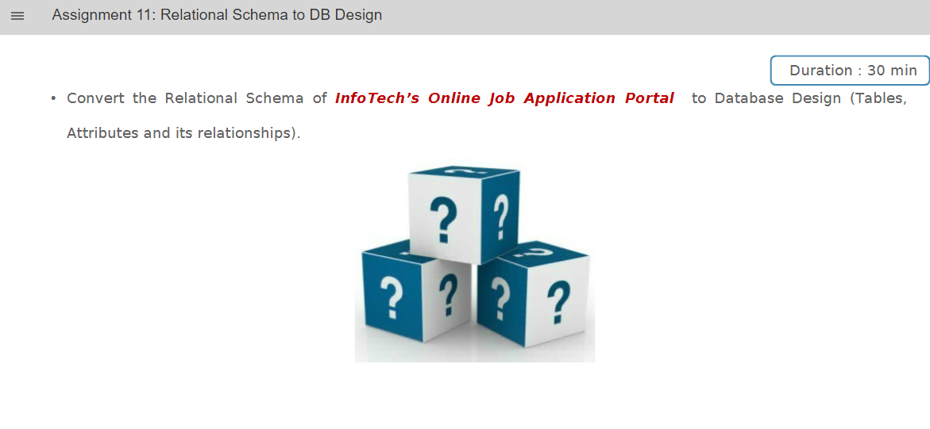

**A)**

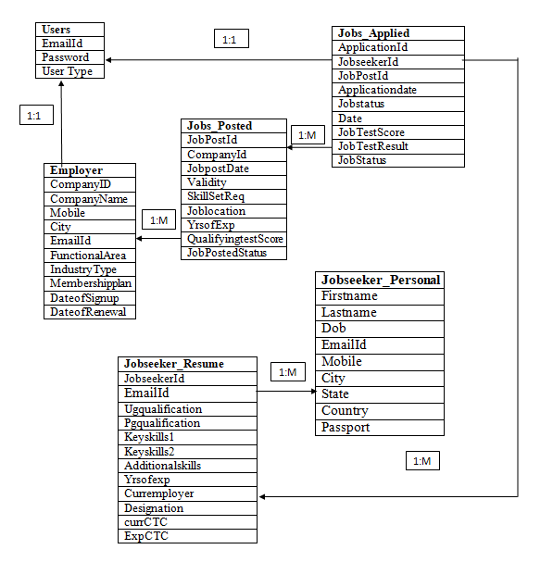

# Assignment 12:

**Q)**

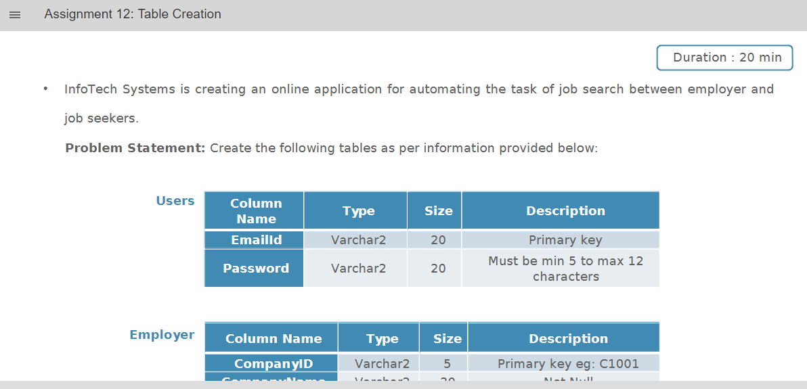

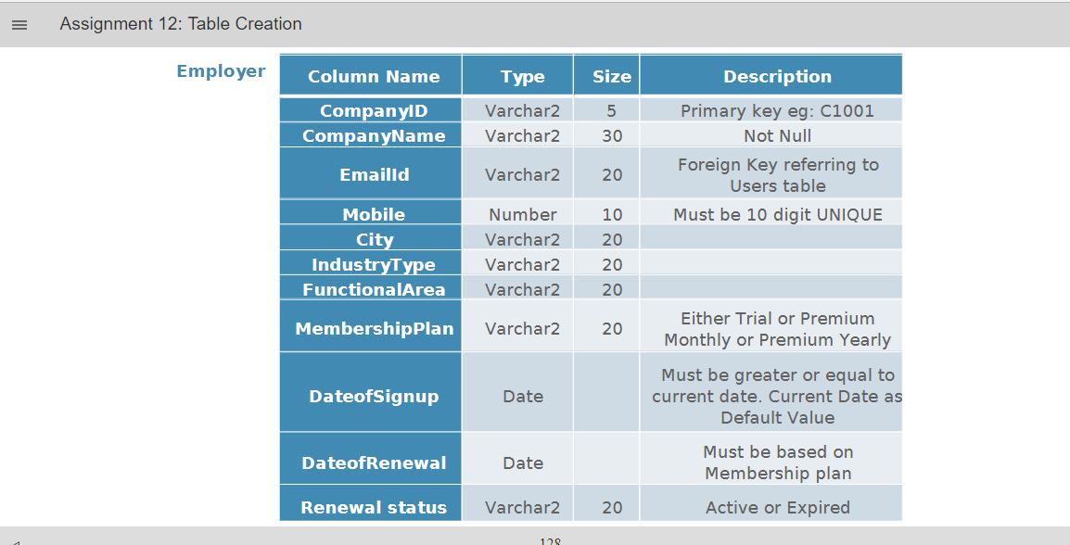

**A)**

1.

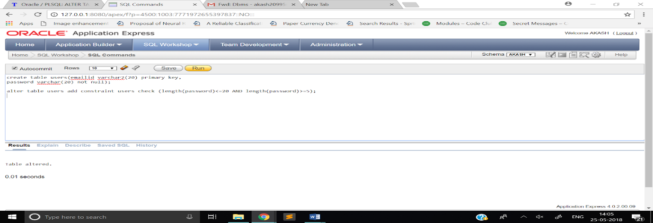

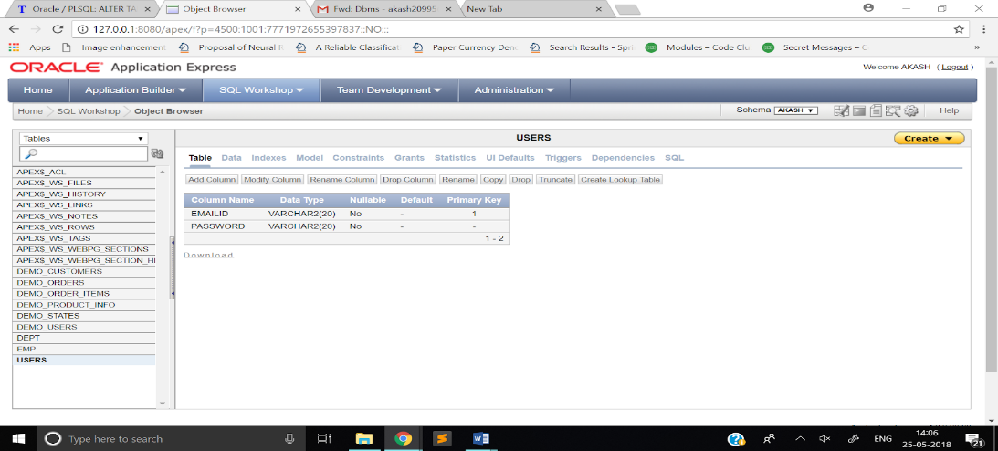

2.

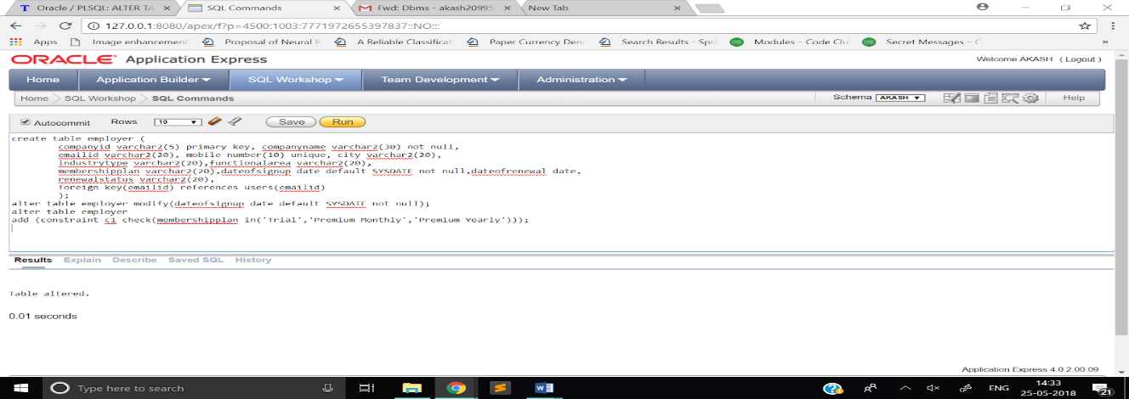

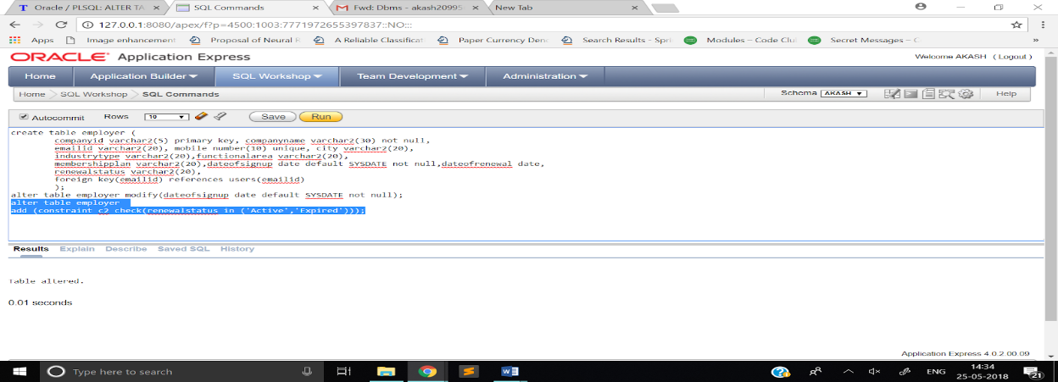

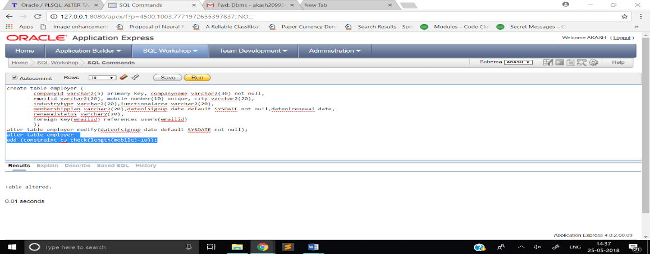

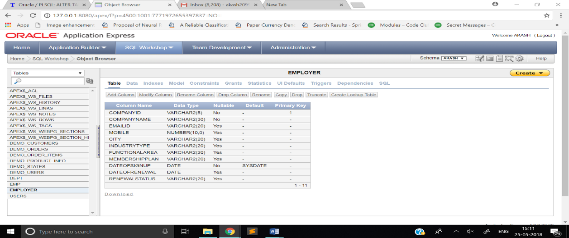

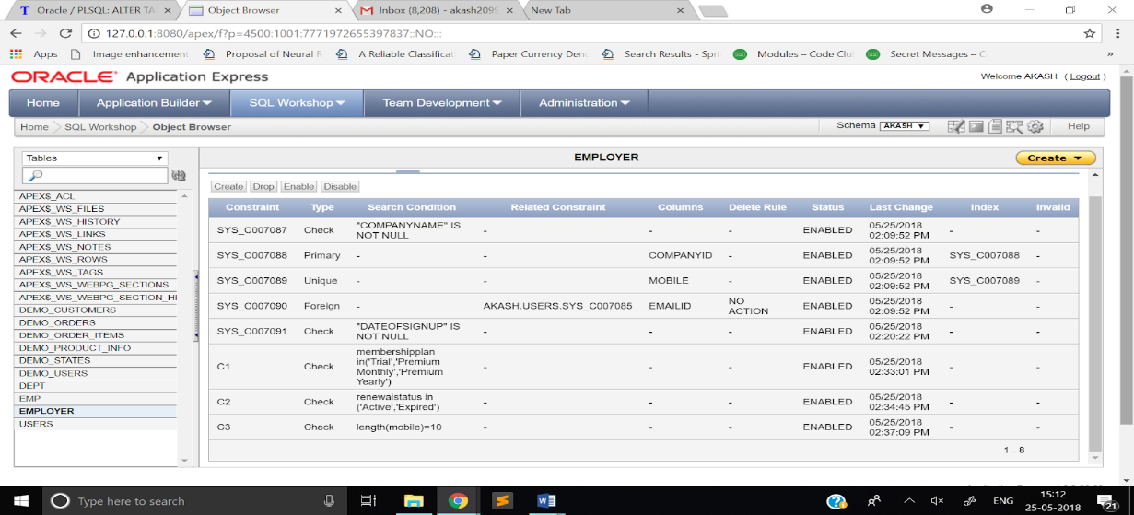

Assignment 14:  
**Q)**

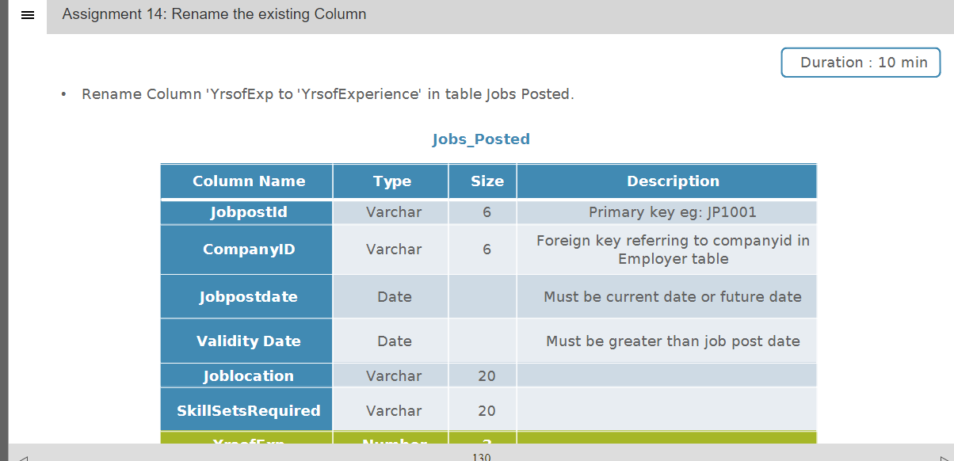

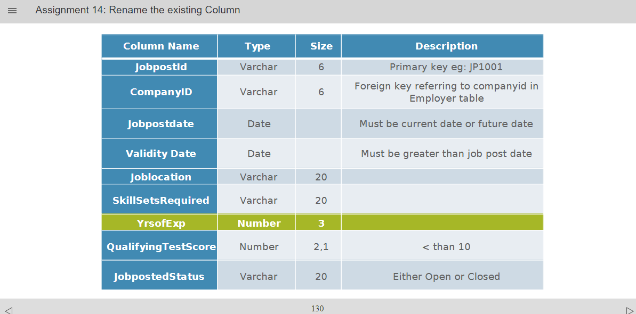

**A)**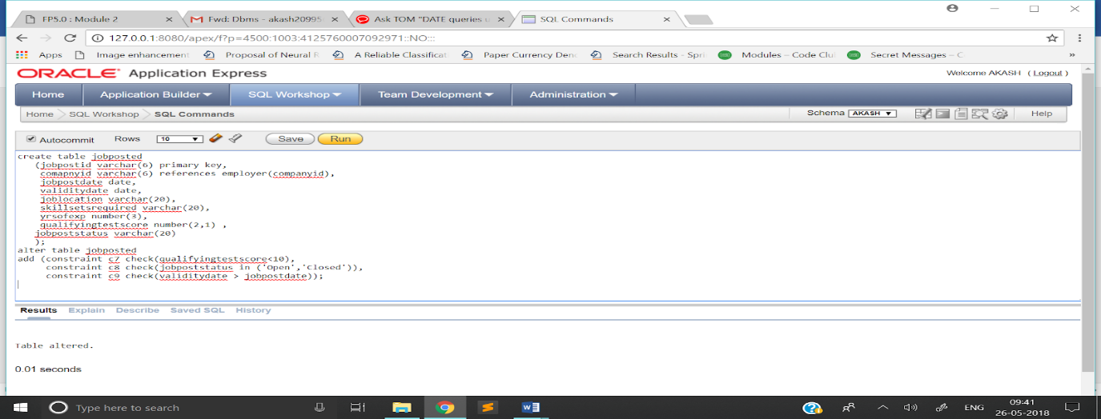

# Assignment 15:

**Q)**

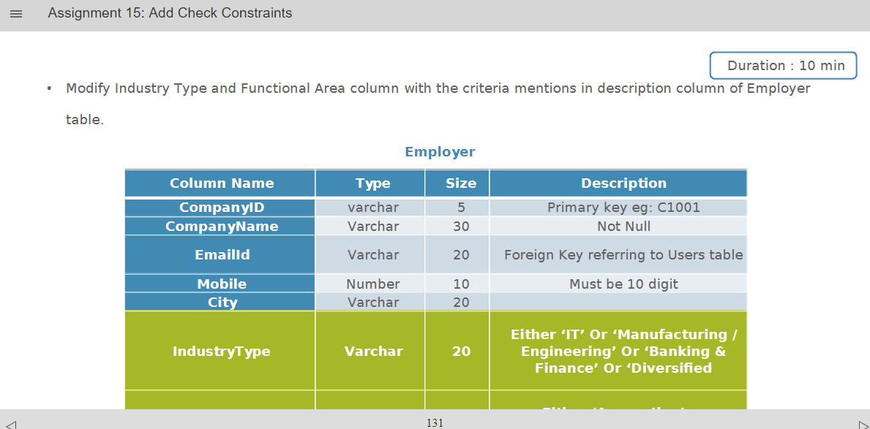

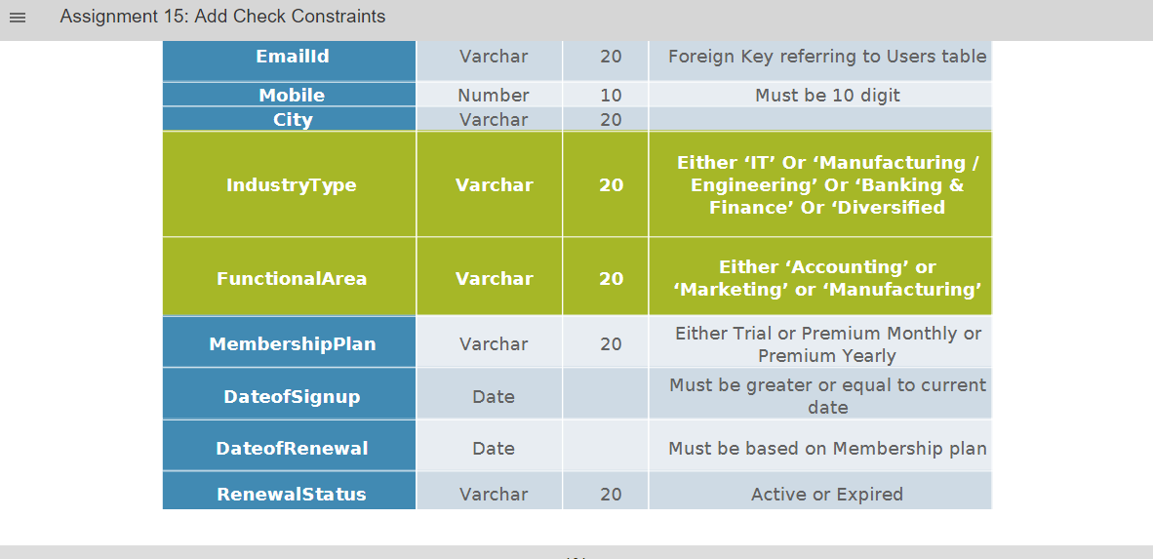

**A)**

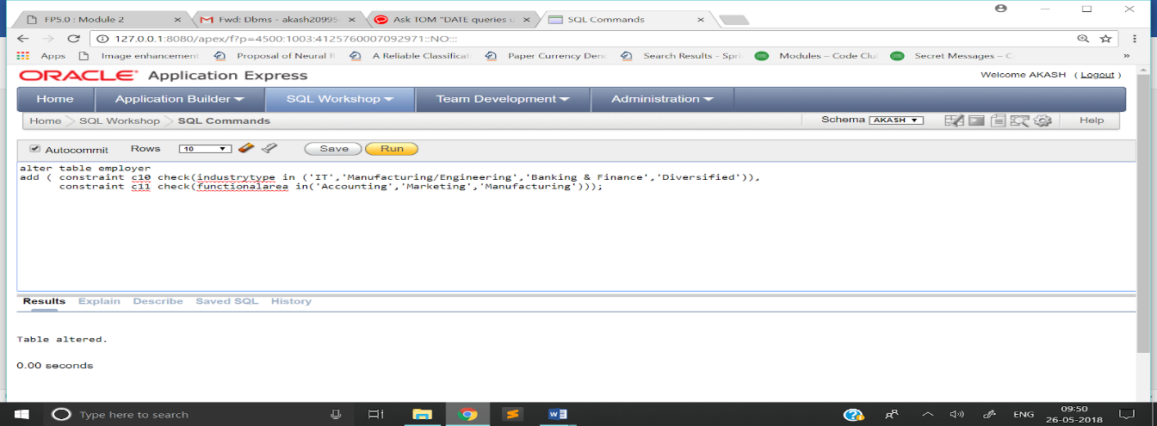

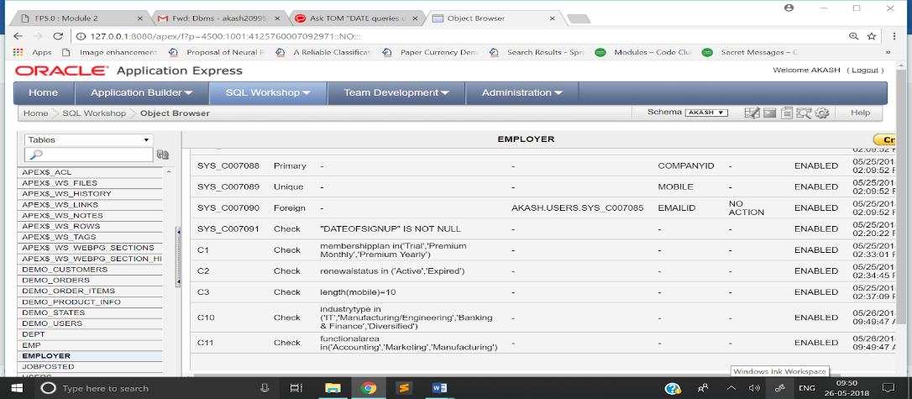

# Assignment 16:

**Q)**

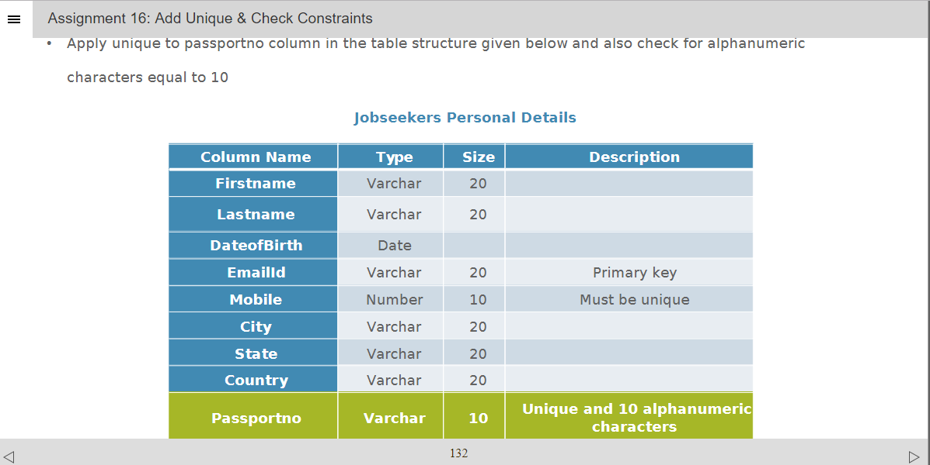

**A)**

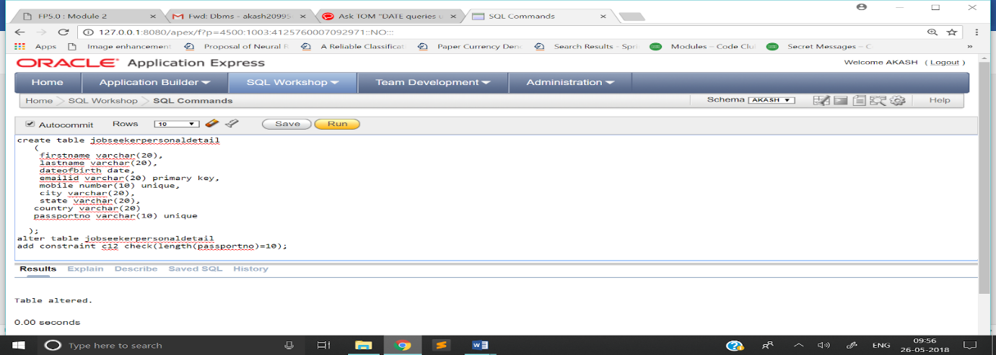

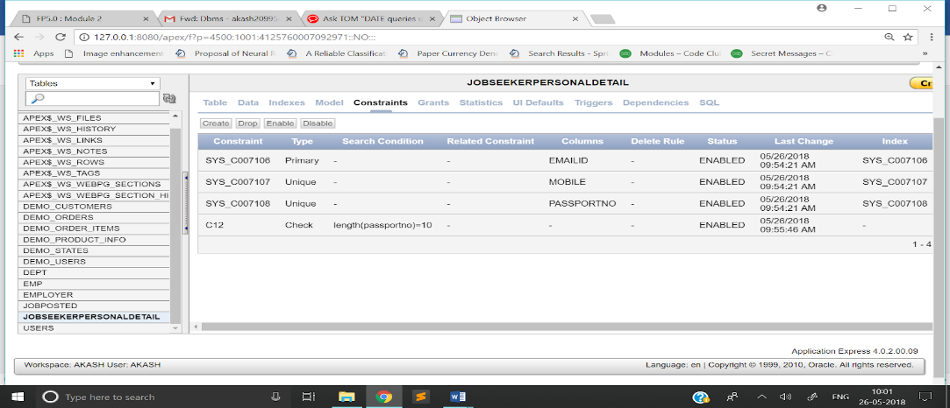

# Assignment 17:

**Q)**

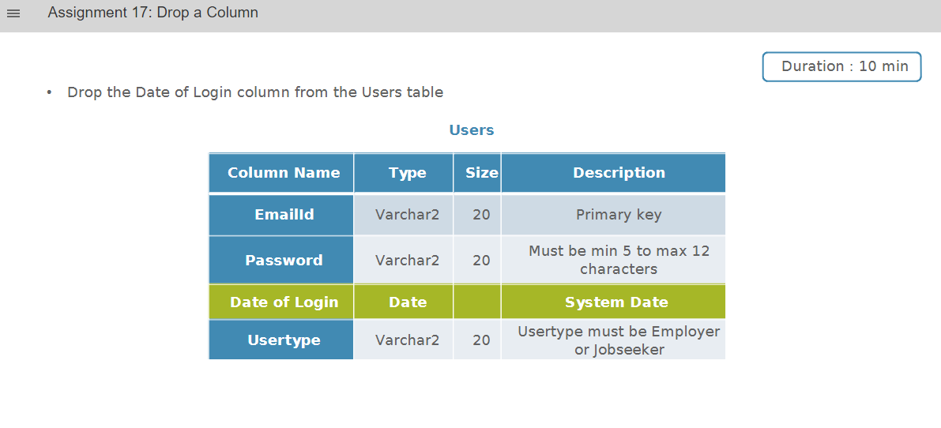

**A)**

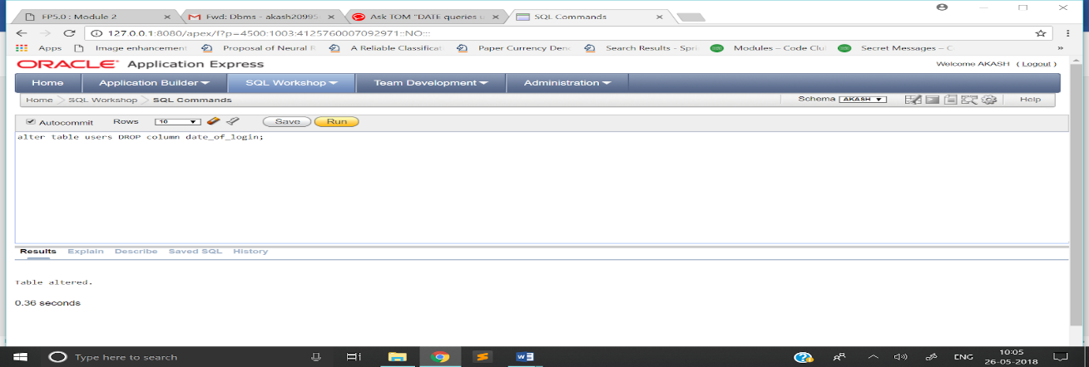

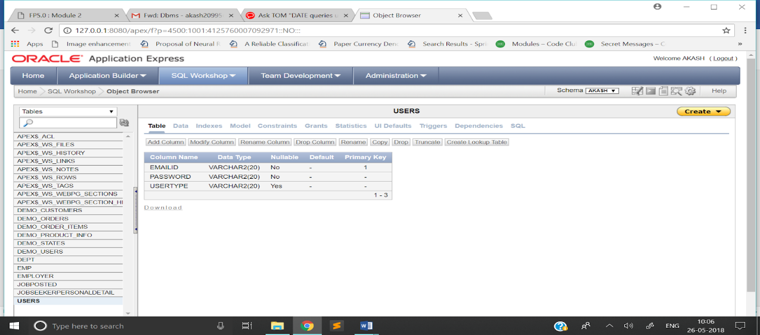

# Assignment 18:

**Q)**

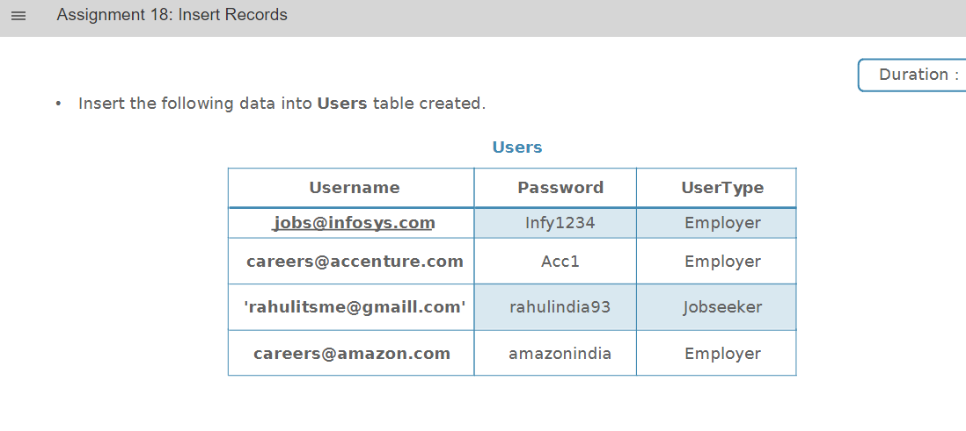

**A)**

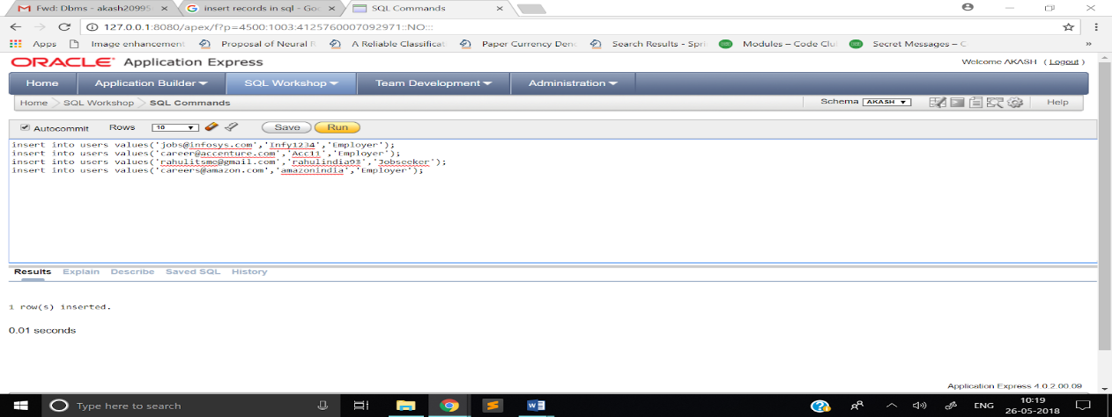

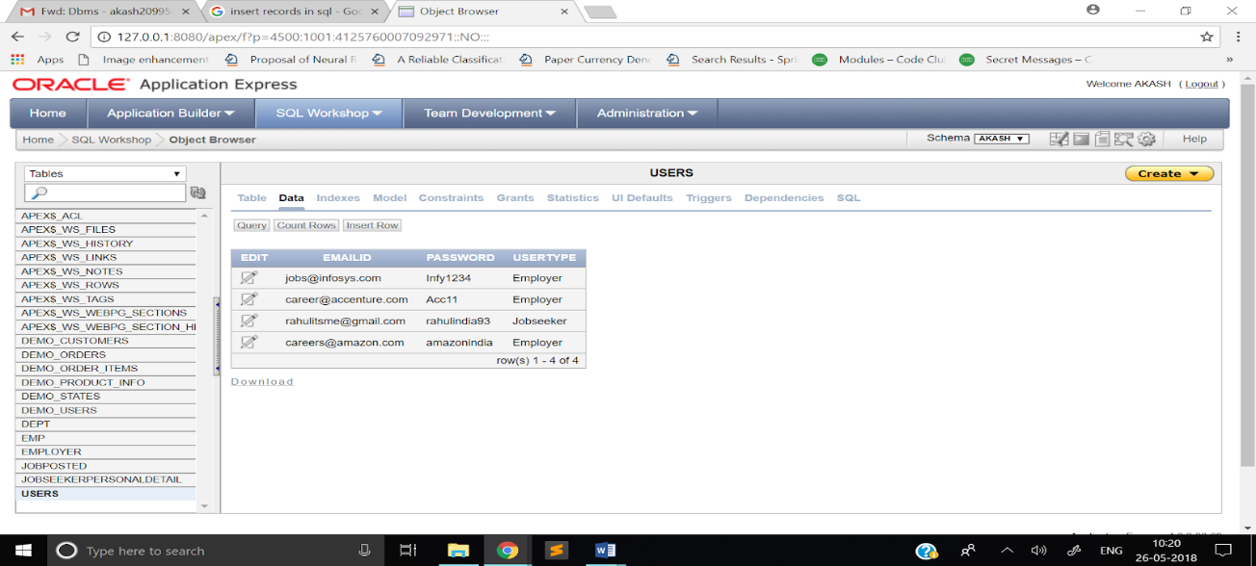

# Assignment 19:

**Q)**

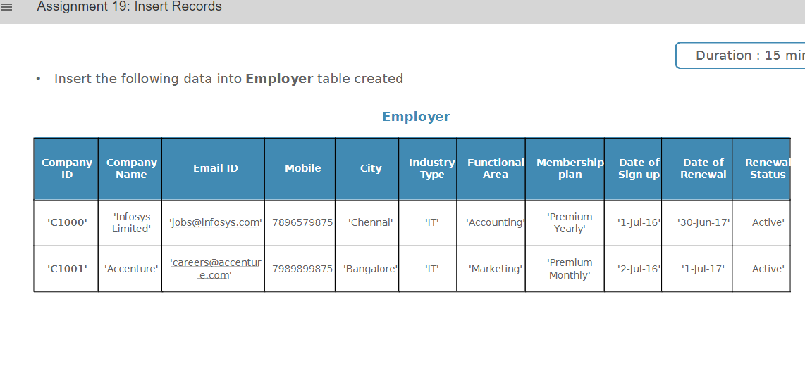

**A)**

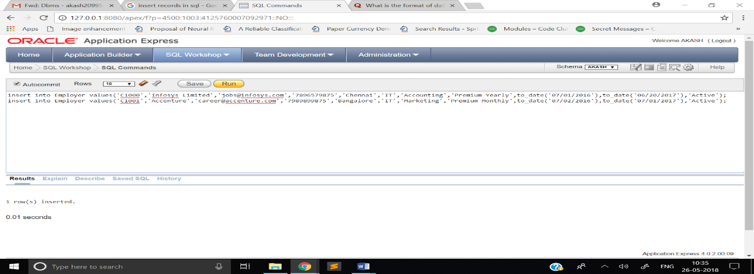

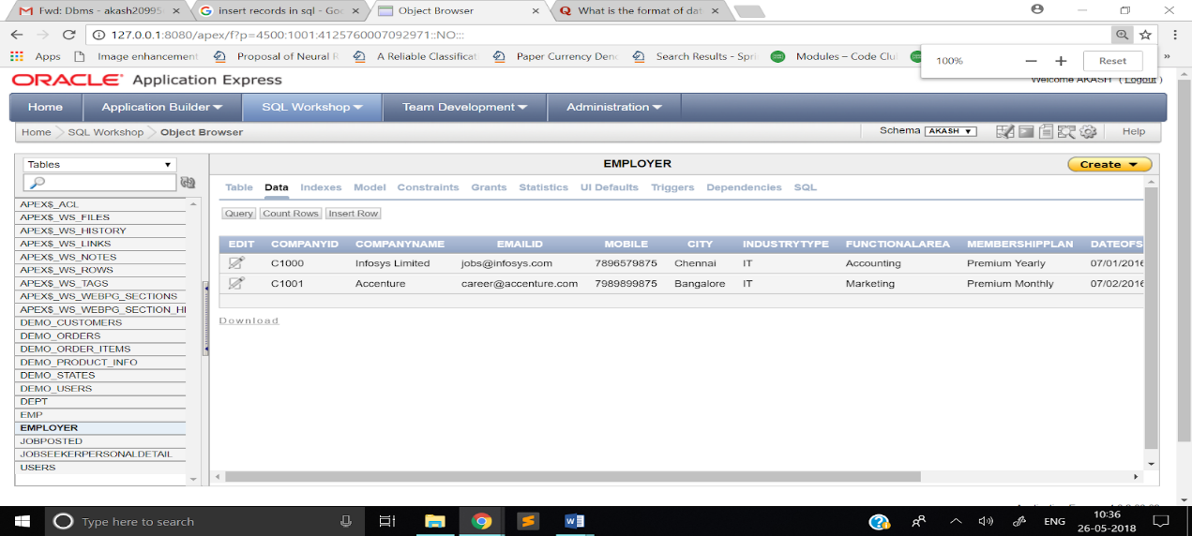

# Assignment 20:

**Q)**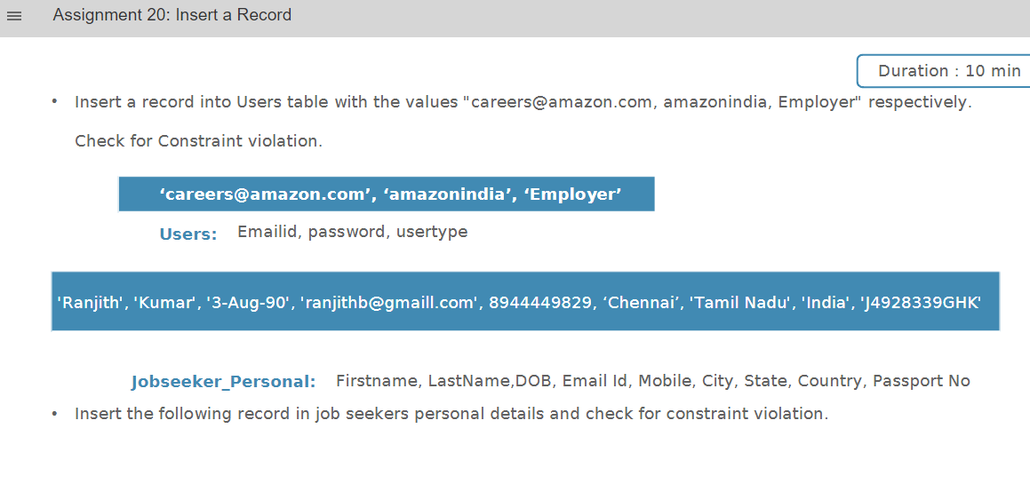

**A)**

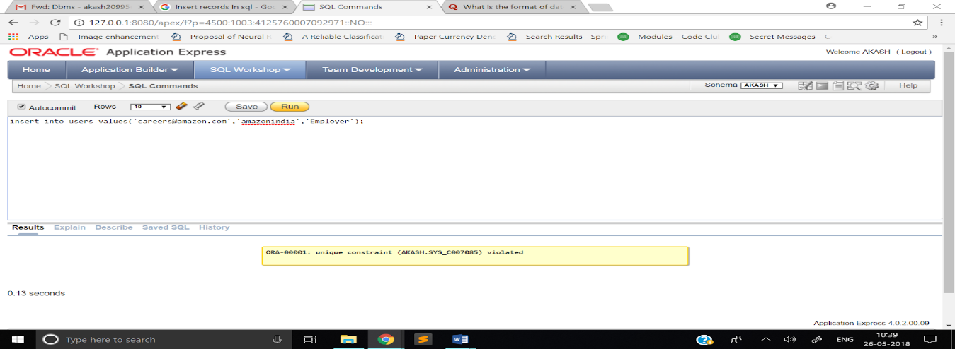

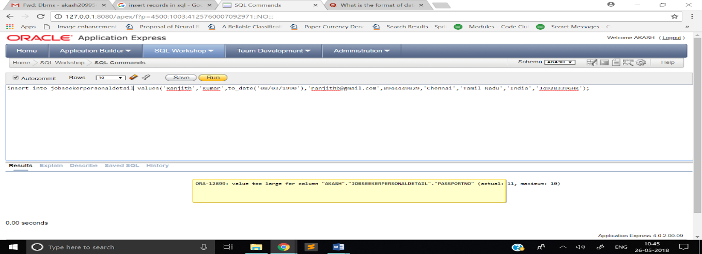

# Assignment 21:

**Q)**

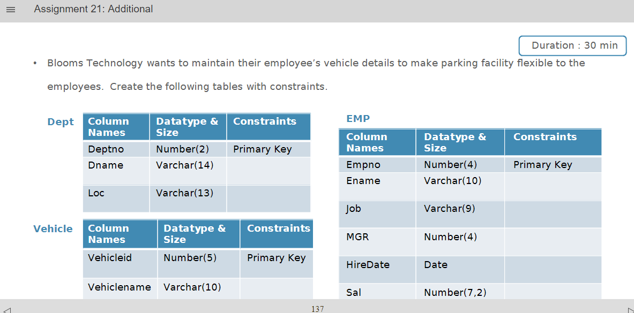

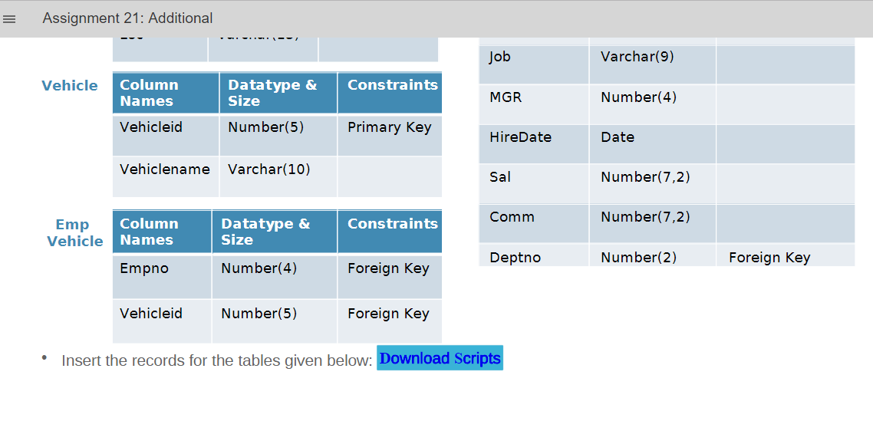

**A)**

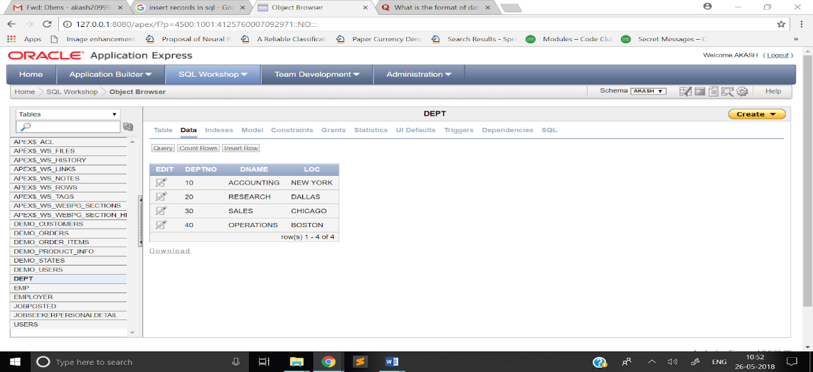

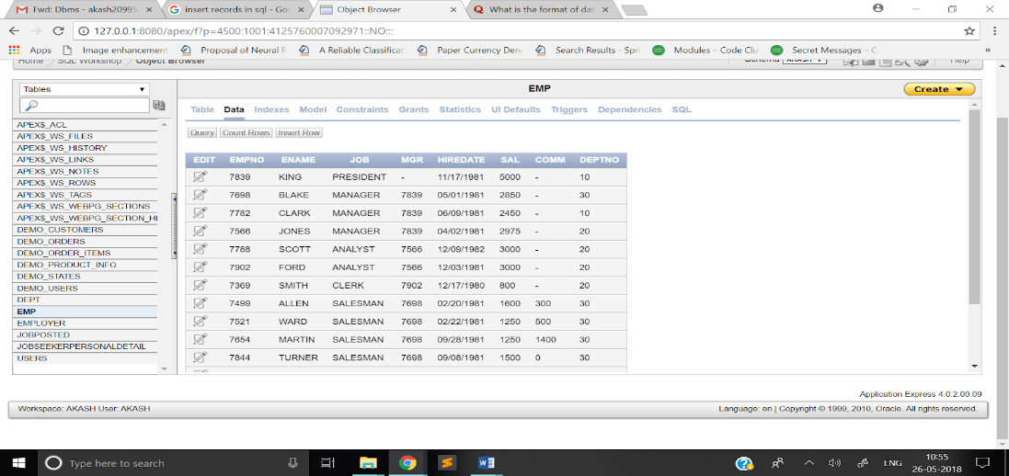

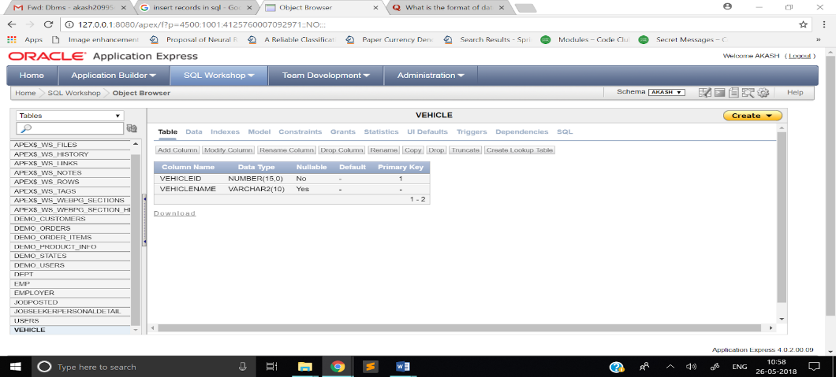

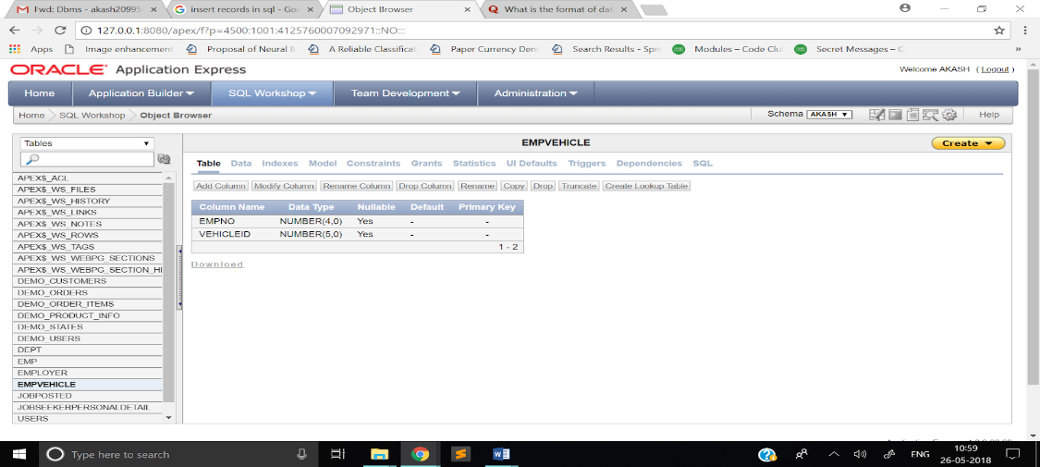

# Assignment 22:

**Q)**

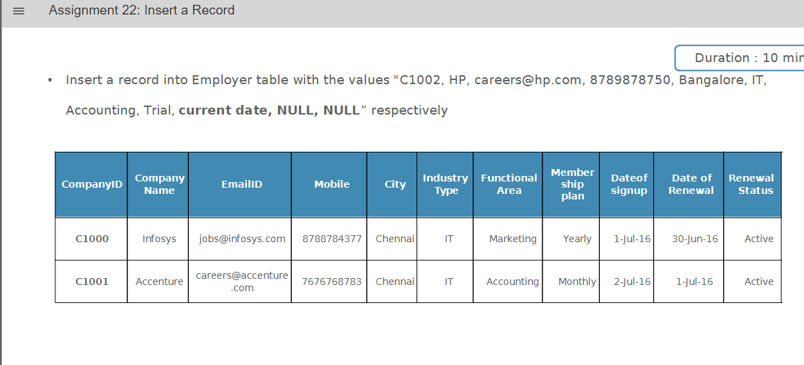

**A)**

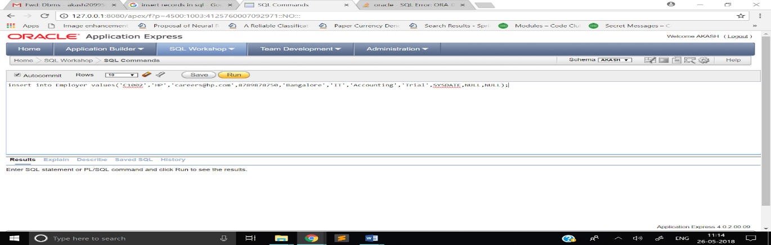

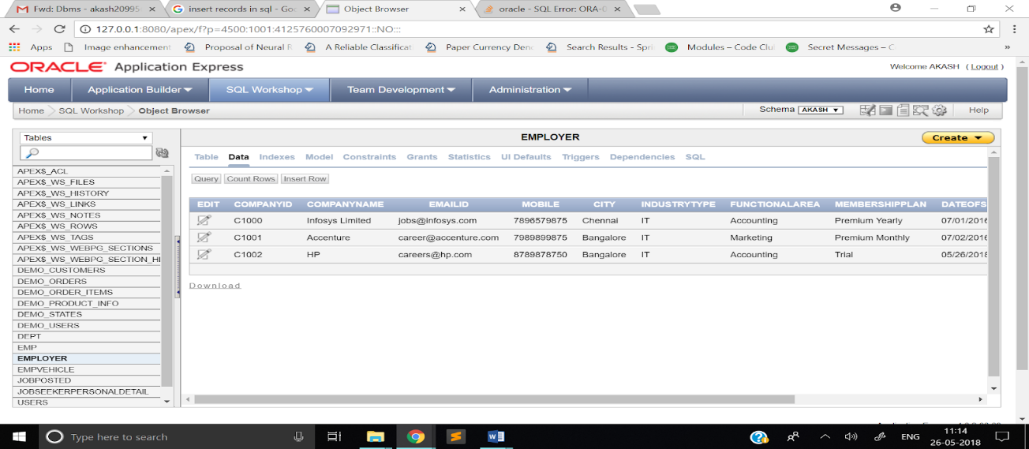

# Assignment 23:

**Q)**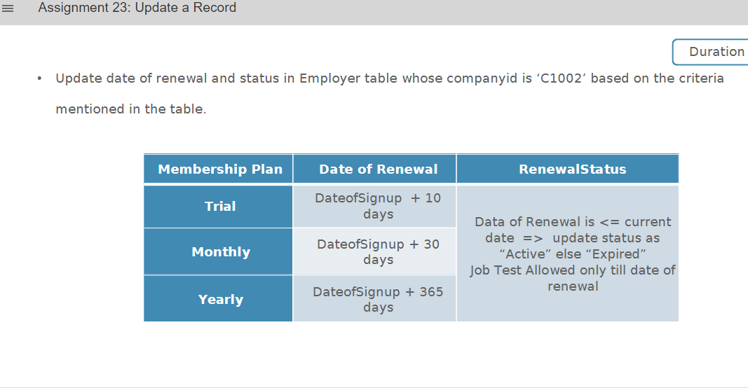

**A)**

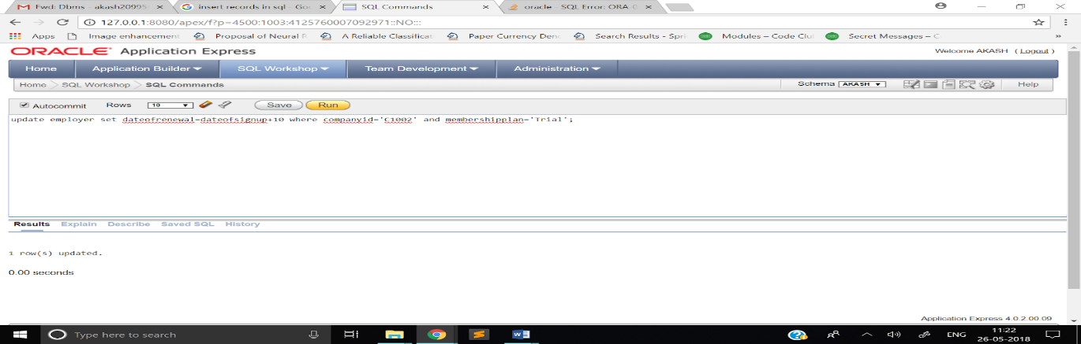

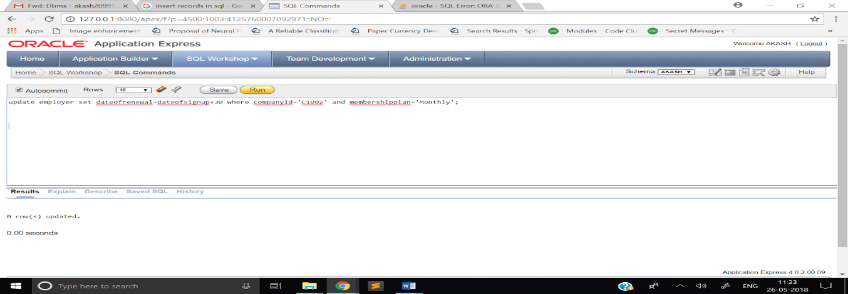

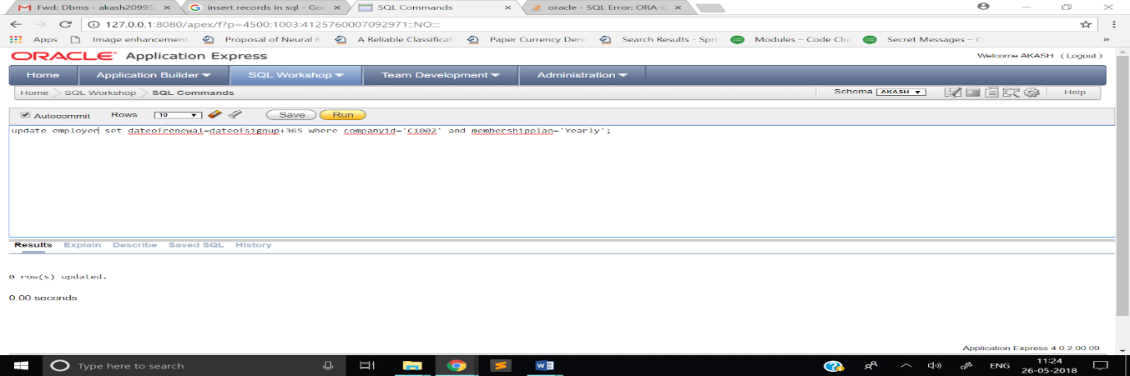

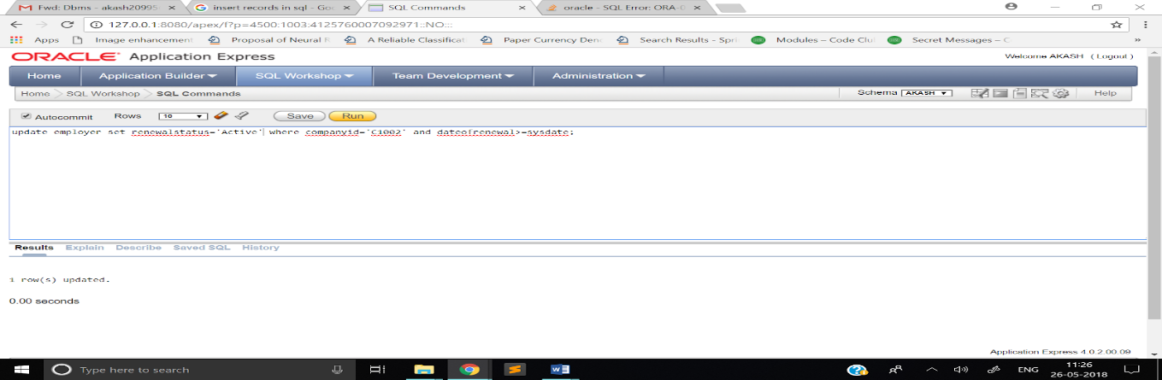

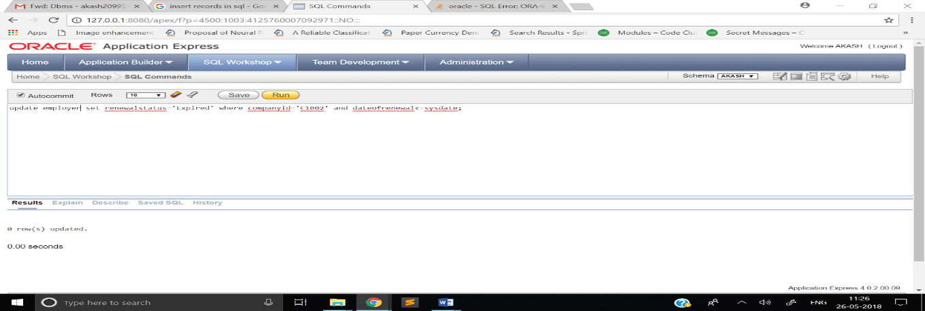

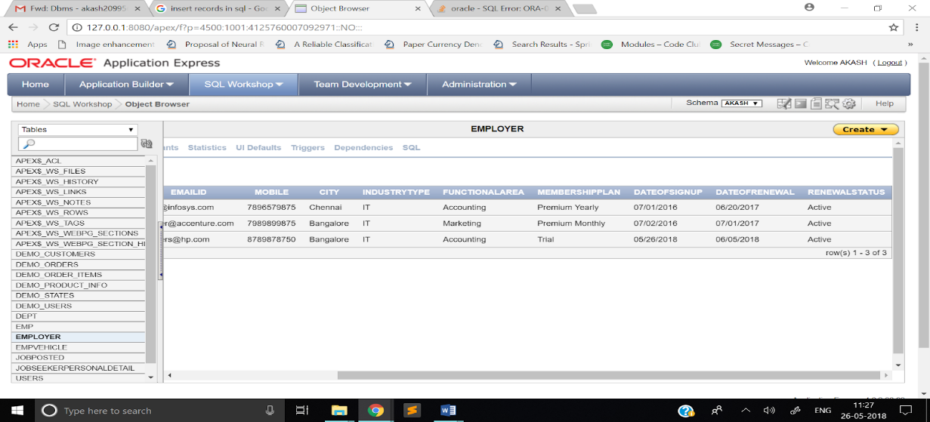

# Assignment 24:

**Q)**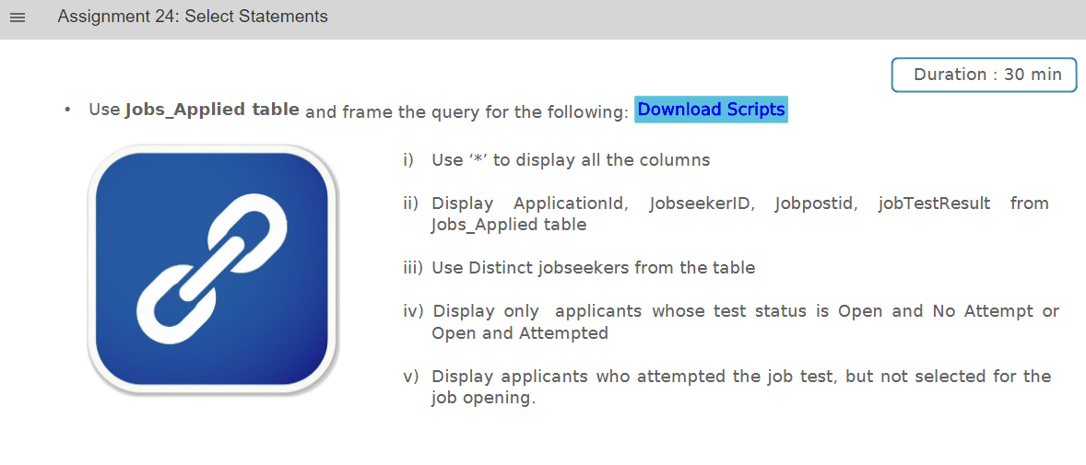

**A)**

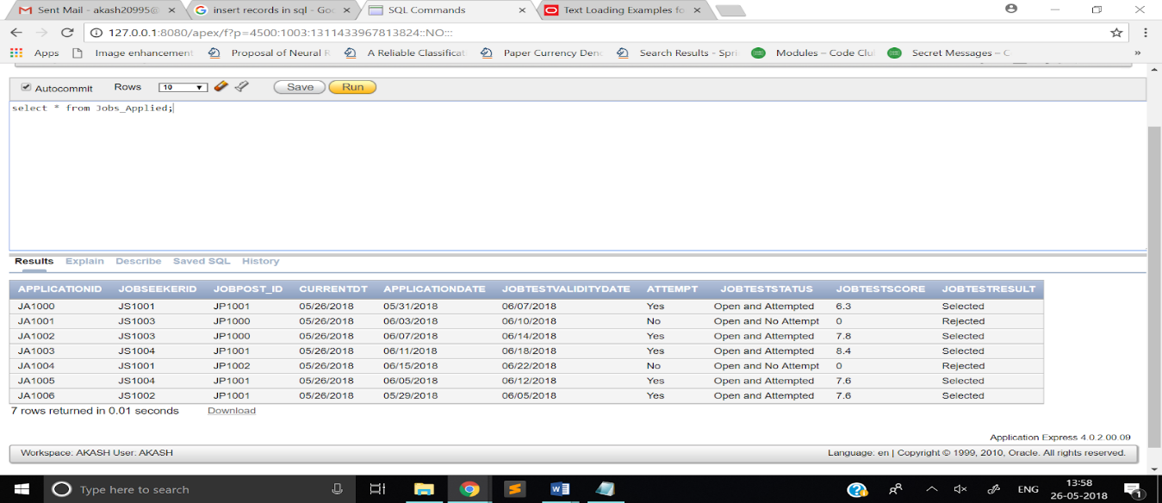

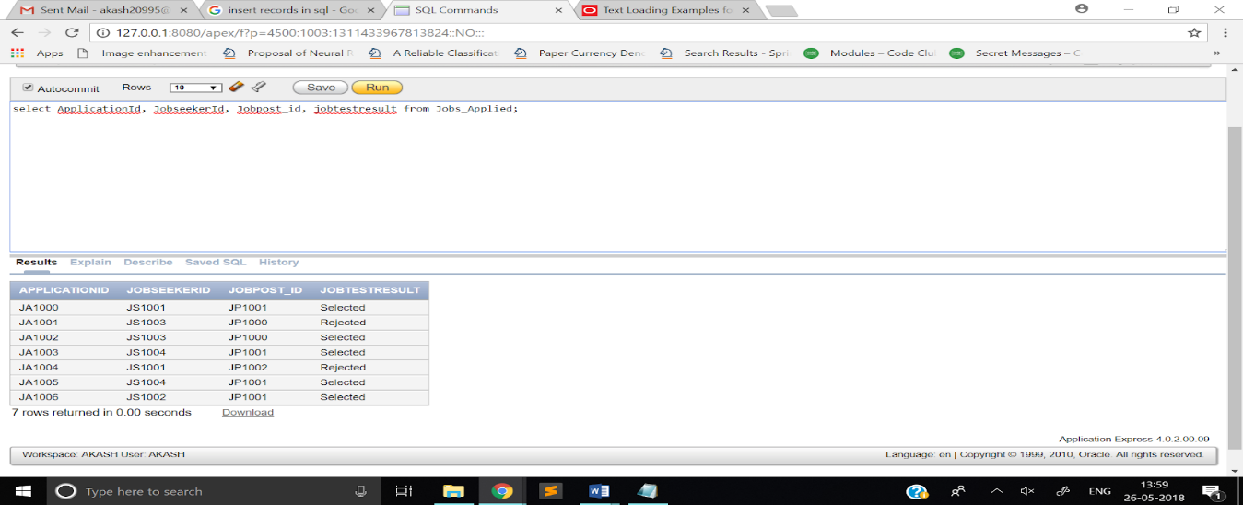

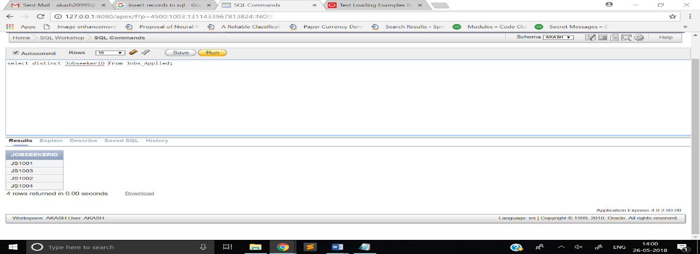

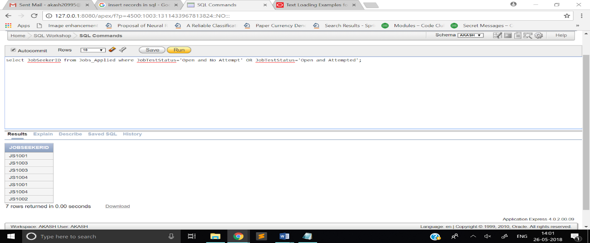

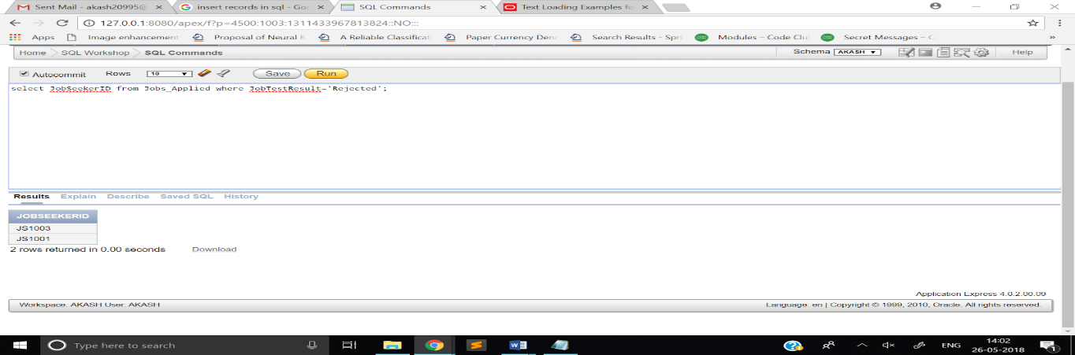

# Assignment 25:

**Q)**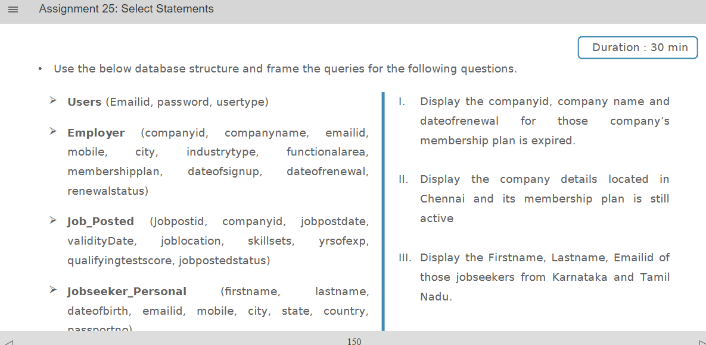

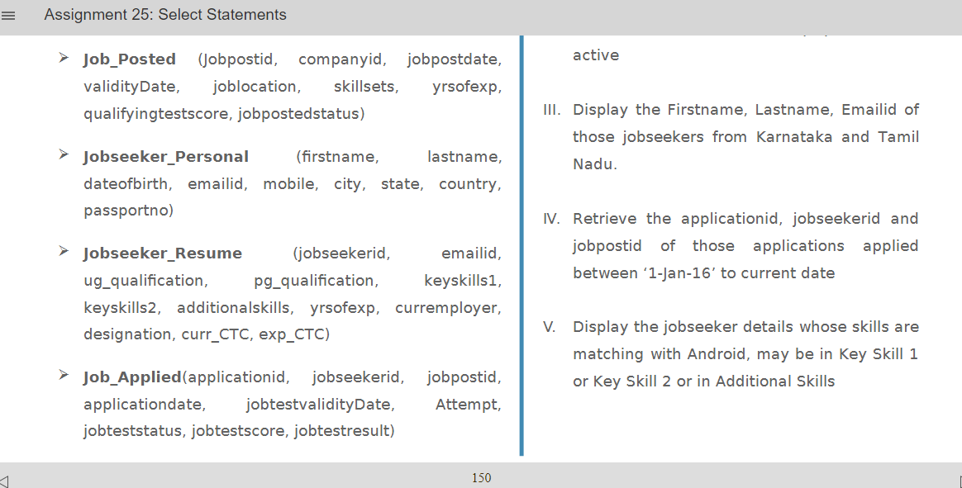

**A)**

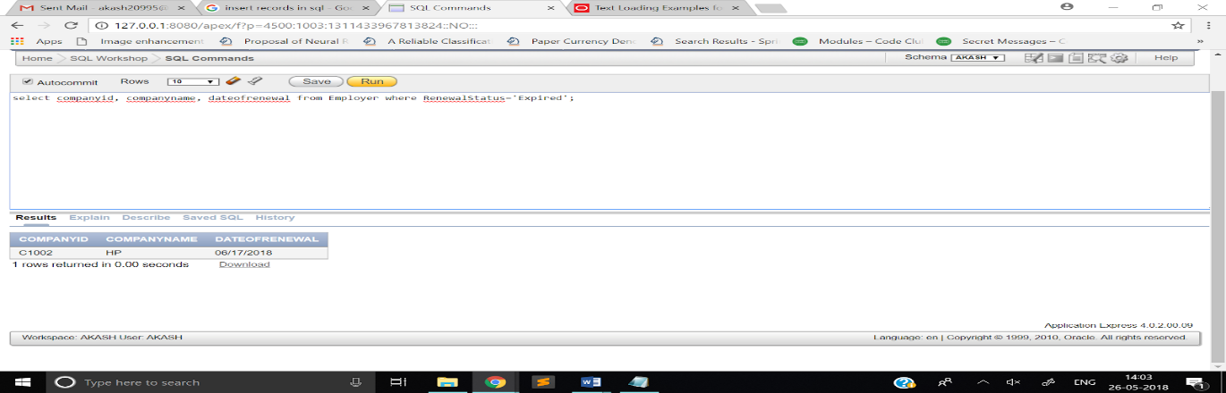

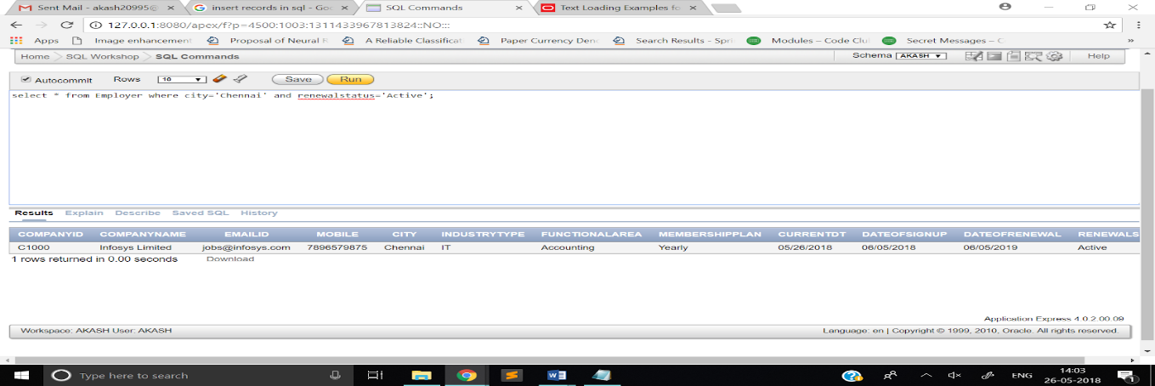

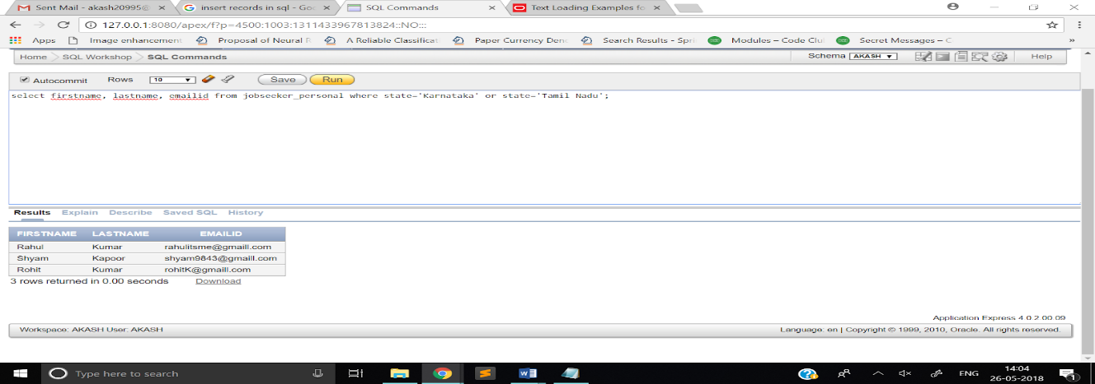

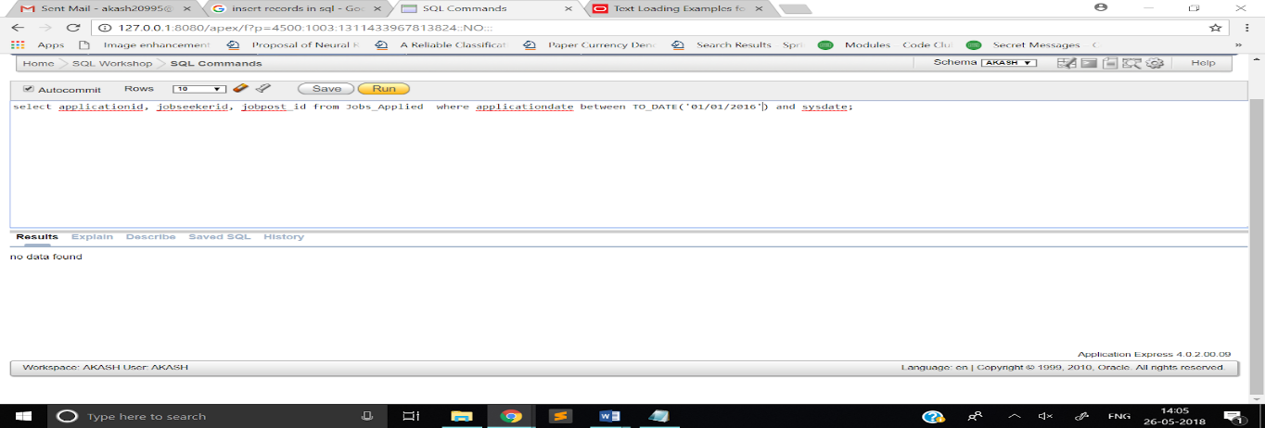

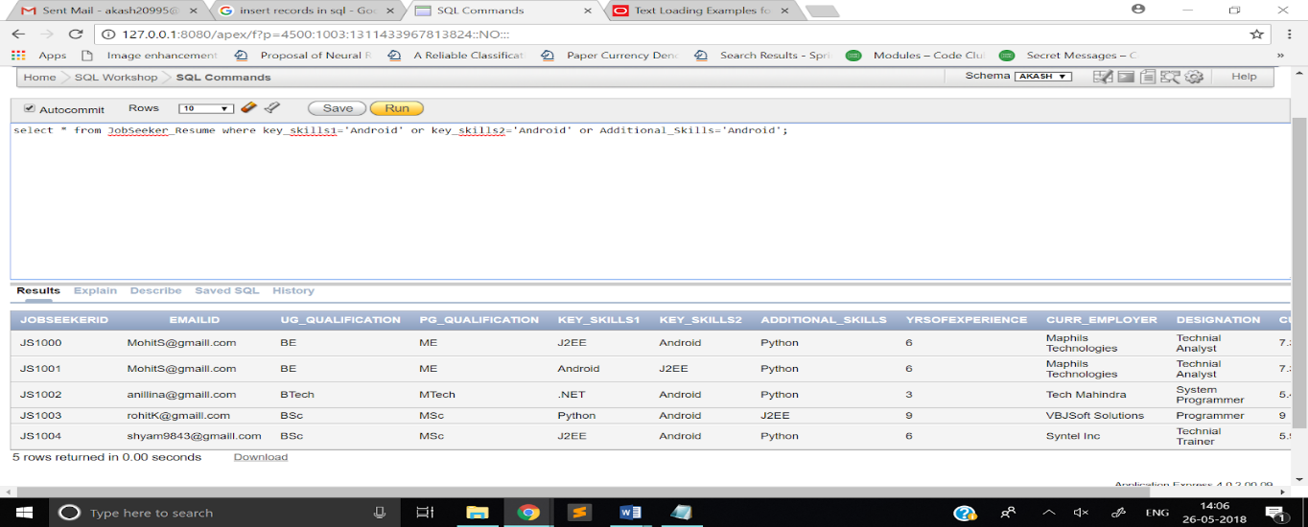

# Assignment 26:

**Q)**

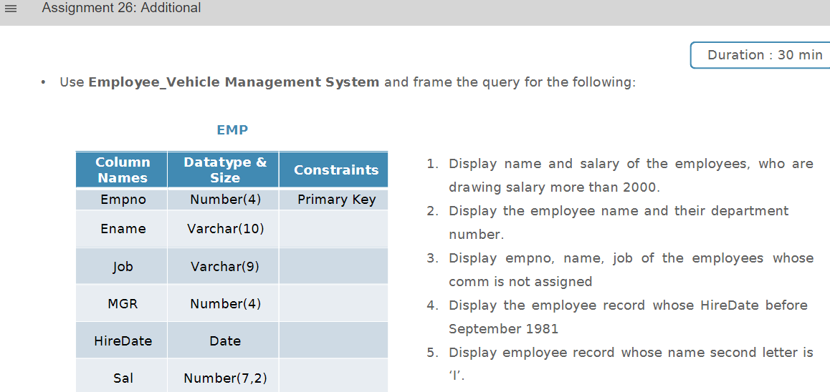

**A)**

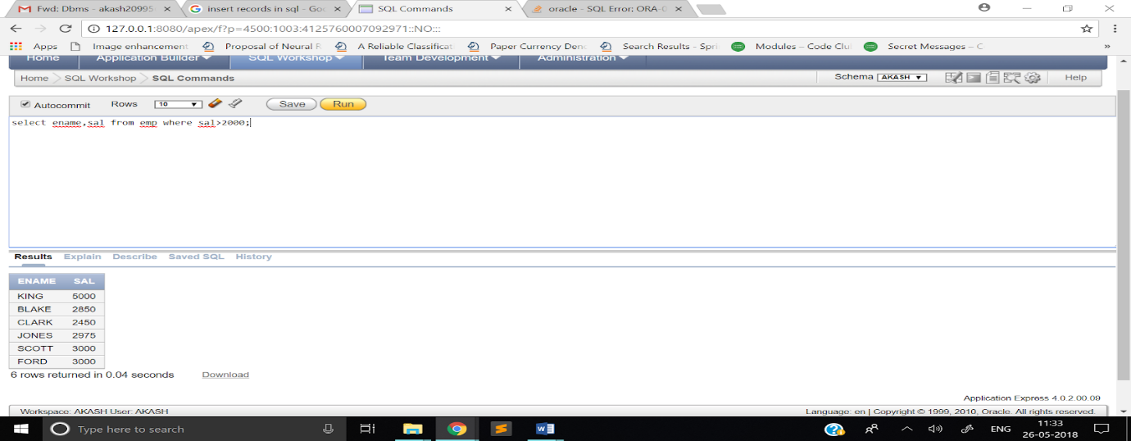

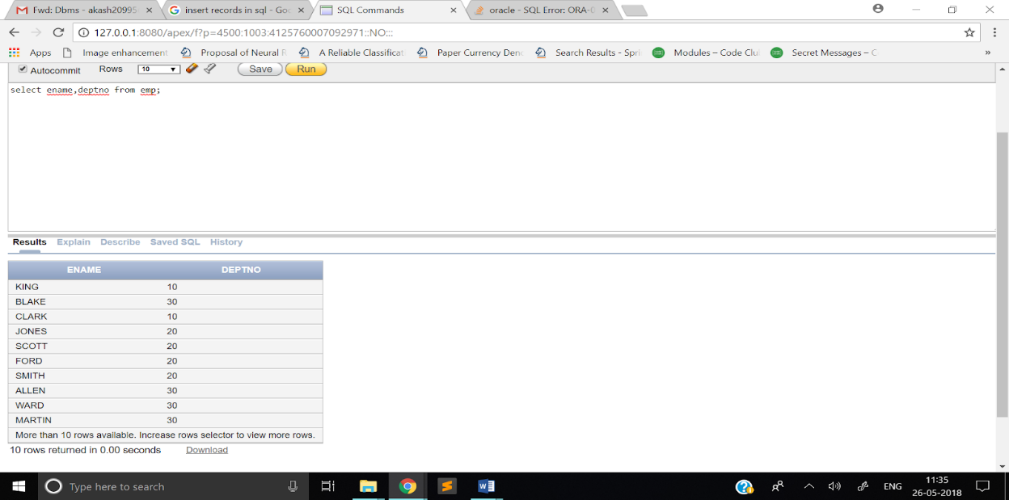

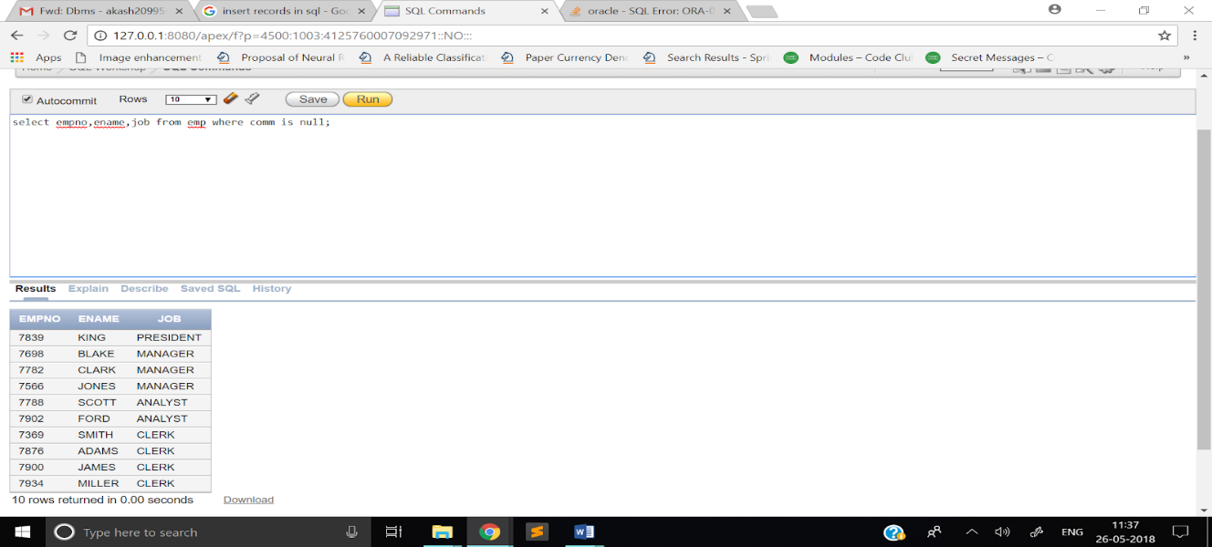

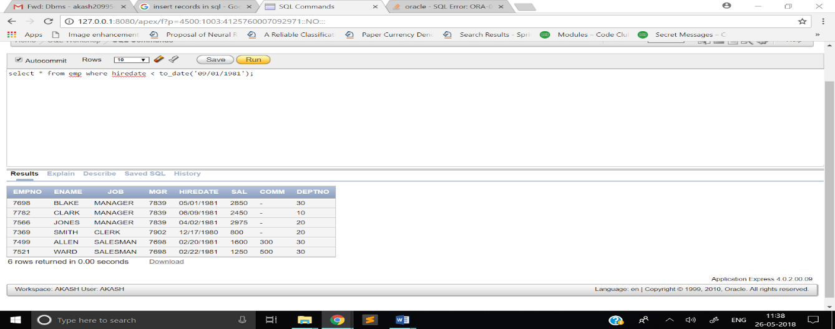

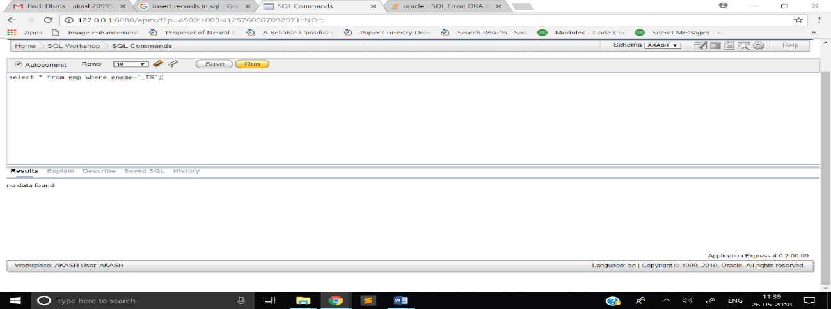

# Assignment 27:

**Q)**

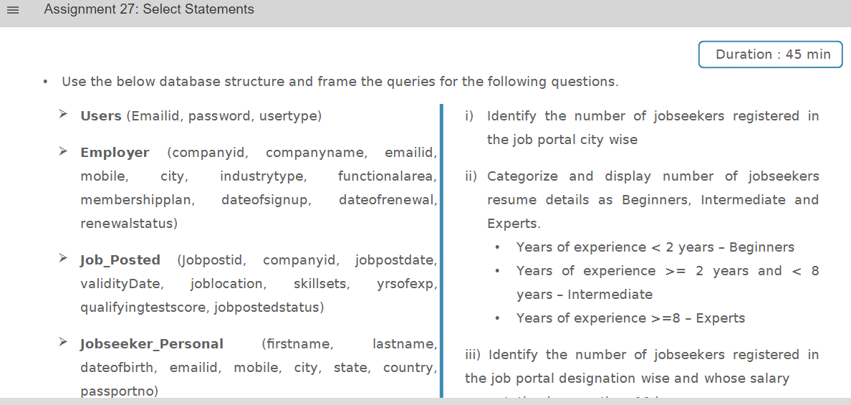

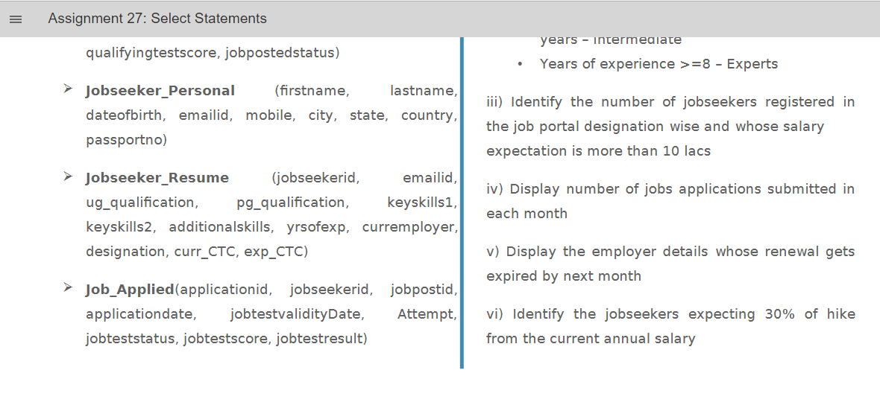

**A)**

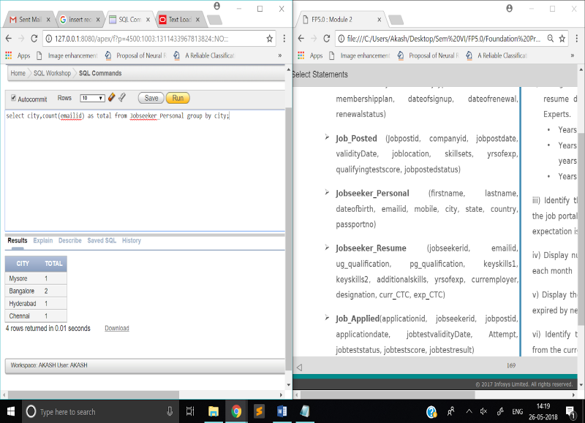

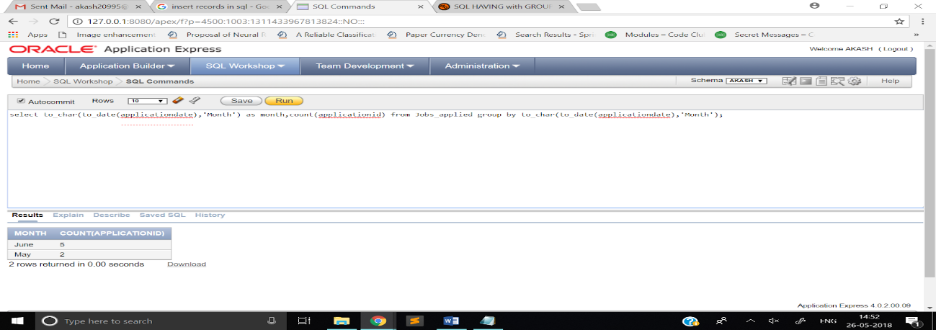

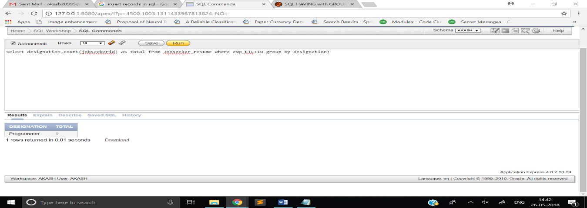

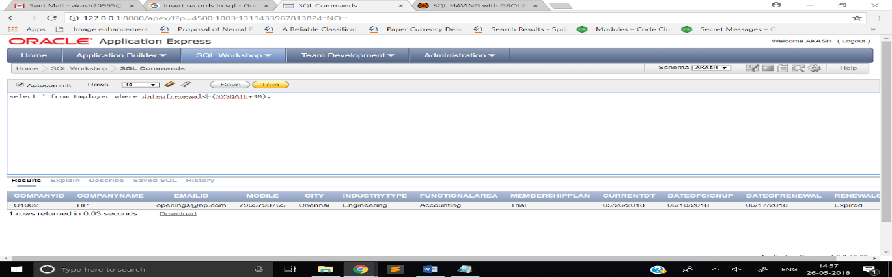

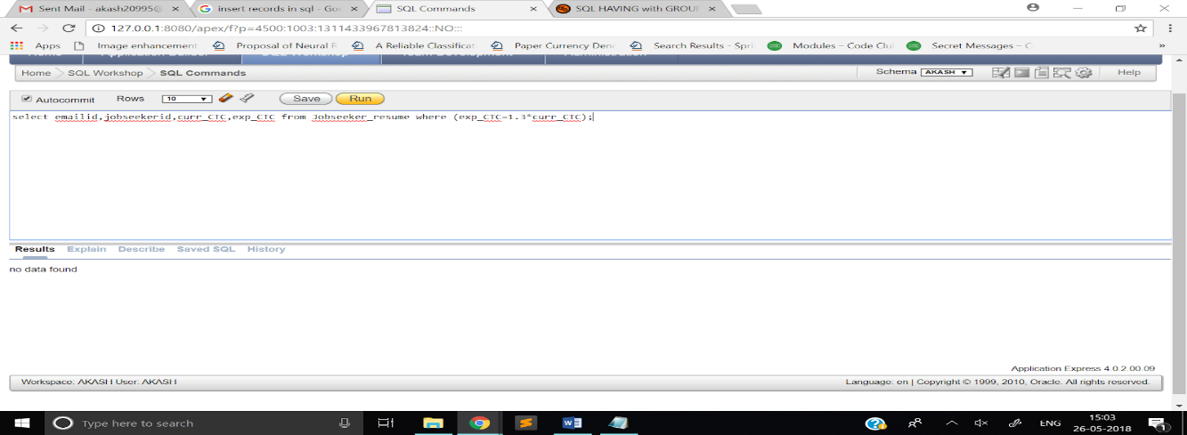

# Assignment 28:

**Q)**

